**Assignment for Outlier in Placement Dataset – 25.05.2024**

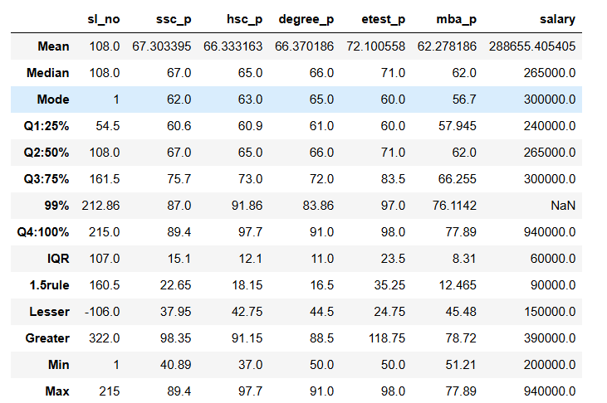

**Lesser and Greater Outlier values:**

|  |  |
| --- | --- |
| SSC_P lesser outlier is 37.95 | SSC_P greater outlier is 98.35 |
| HSC_P lesser outlier is 42.75 | HSC_P greater outlier is 91.15 |
| Degree_P lesser outlier is 44.5 | Degree_P greater outlier is 88.5 |
| Etest_P lesser outlier is 24.75 | Etest_P greater outlier is 118.75 |
| MBA_P lesser outlier is 45.48 | MBA_P greater outlier is 78.72 |
| Salary lesser outlier is 150000 | Salary greater outlier is 390000 |

**Dataset value of Minimum and Maximum:**

|  |  |
| --- | --- |
| SSC_P min is 40.89 | SSC_P max is 89.4 |
| HSC_P min is 37.0 | HSC_P max is 97.7 |
| Degree_P min is 50.0 | Degree_P max is 91.0 |
| Etest_P min is 50.0 | Etest_P max is 98.0 |
| MBA_P min is 51.21 | MBA_P max is 77.89 |
| Salary min is 200000 | Salary max is 940000 |

**Finding the Lesser & Greater outliers with comparison of Dataset values:**

|  |  |  |  |  |  |
| --- | --- | --- | --- | --- | --- |
| Lesser outlier | Min value in Dataset | Outlier Found/  Not found | Greater outlier | Max value in Dataset | Outlier Found/  Not found |
| SSC_P - 37.95 | 40.89 | Not found | SSC_P - 98.35 | 89.4 | Not found |
| HSC_P - 42.75 | 37.0 | Outlier Found | HSC_P - 91.15 | 97.7 | Outlier Found |
| Degree_P - 44.5 | 50.0 | Not found | Degree_P – 88.5 | 91.0 | Outlier Found |
| Etest_P - 24.75 | 50.0 | Not found | Etest_P - 118.75 | 98.0 | Not found |
| MBA_P - 45.48 | 51.21 | Not found | MBA_P - 78.72 | 77.89 | Not found |
| Salary - 150000 | 200000 | Not found | Salary - 390000 | 940000 | Outlier Found |

In Dataset Lesser outlier found in HSC_P is 37.0 .

In Dataset Greater outlier found in HSC_P is 97.7, Degree_P is 91.0 and Salary – 940000.